COS20019
Cloud Computing Architechture
Truong Ngoc Gia Hieu
105565520
Week 5 – ACF Lab 5:
RDS lab (Build a Database Server)
Lab 5: Build Your DB Server and Interact With Your DB Using an App

A. Lab Overview and objectives

This lab is designed to reinforce the concept of leveraging an AWS-managed database instance for solving relational database needs.

Amazon Relational Database Service (Amazon RDS) makes it easy to set up, operate, and scale a relational database in the cloud. It provides cost-efficient and resizable capacity while managing time-consuming database administration tasks, which allows you to focus on your applications and business. Amazon RDS provides you with six familiar database engines to choose from: Amazon Aurora, Oracle, Microsoft SQL Server, PostgreSQL, MySQL and MariaDB.

By the end of this lab, you will be able to:
- Launch an Amazon RDS DB instance with high availability.
- Configure the DB instance to permit connections from your web server.
- Open a web application and interact with your database.

Duration
This lab takes approximately 30 minutes.

AWS service restrictions
In this lab environment, access to AWS services and service actions might be restricted to the ones that are needed to complete the lab instructions. You might encounter errors if you attempt to access other services or perform actions beyond the ones that are described in this lab.

Scenario
When you start the lab, the following infrastructure is provided:

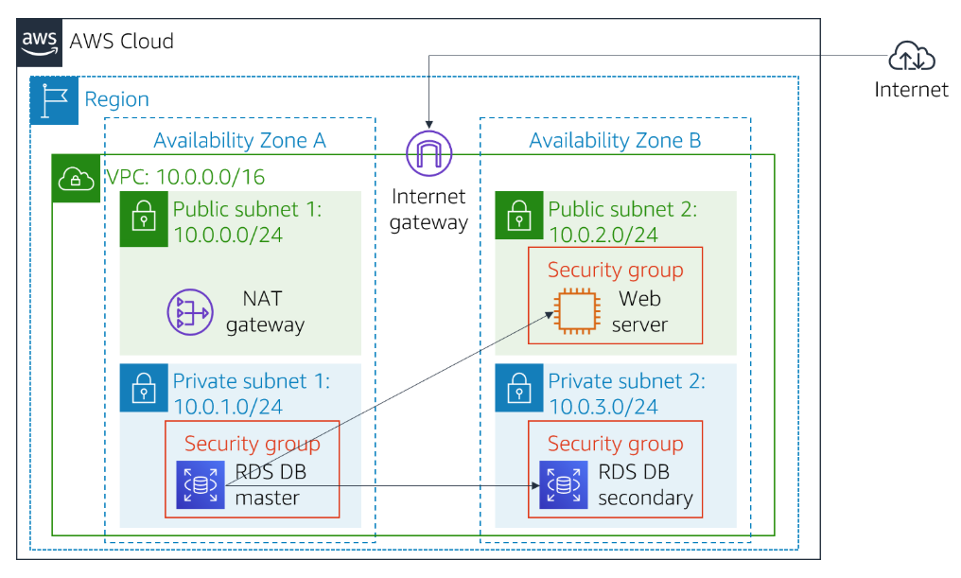
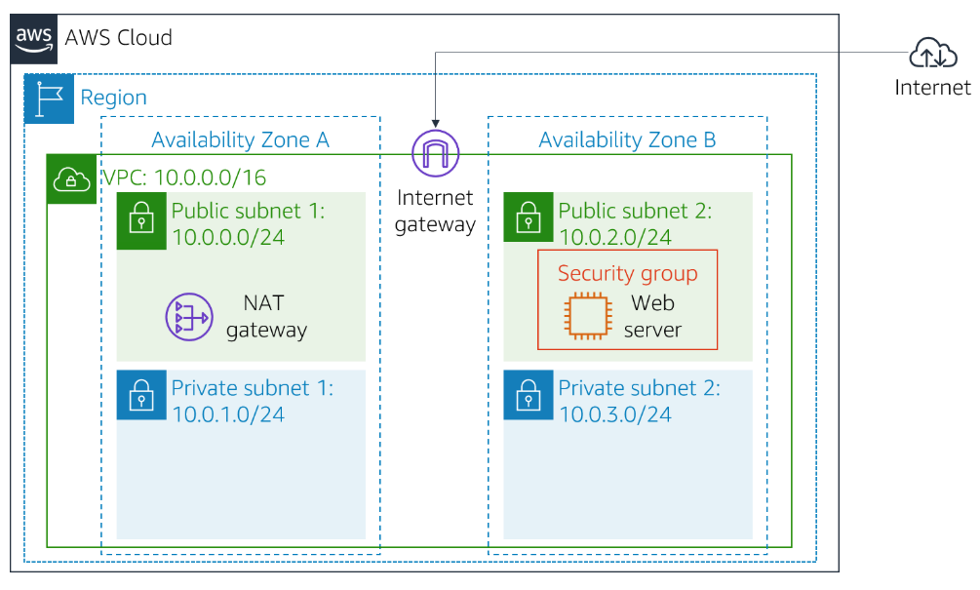
By the end of the lab, you will have this infrastructure:

B. Accessing the AWS Management Console
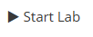
To access the AWS Management Console, clicking the button and wait until the circle next to the AWS changes from yellow to green

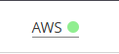

Figure 1: AWS Management Console activated

Getting Credit for your work
At the end of this lab you will be instructed to submit the lab to receive a score based on your progress.
Tip: The script that checks you works may only award points if you name resources and set configurations as specified. In particular, values in these instructions that appear in This Format should be entered exactly as documented (case-sensitive).

C. Task 1: Create a Security Group for the RDS DB Instance
In this task, you will create a security group to allow your web server to access your RDS DB instance. The security group will be used when you launch the database instance.

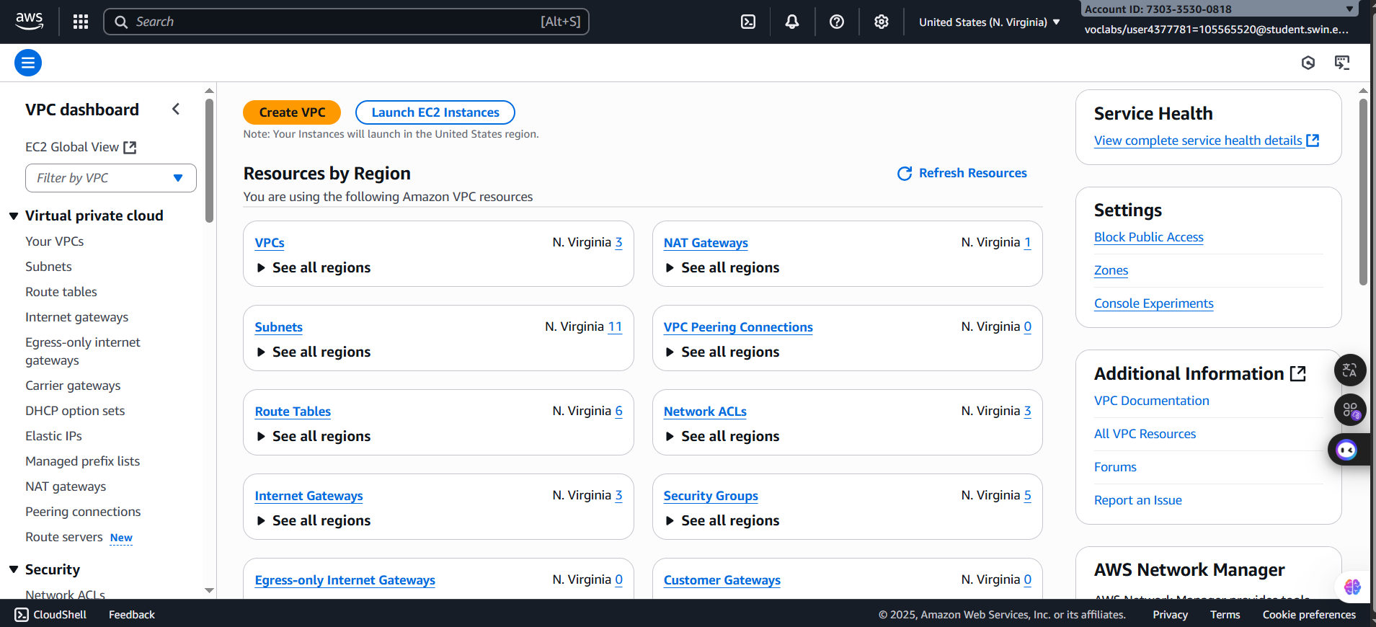
Step 1.1: Open the AWS Management Console Homepage, search and select the VPC
Figure 2: VPC Homepage

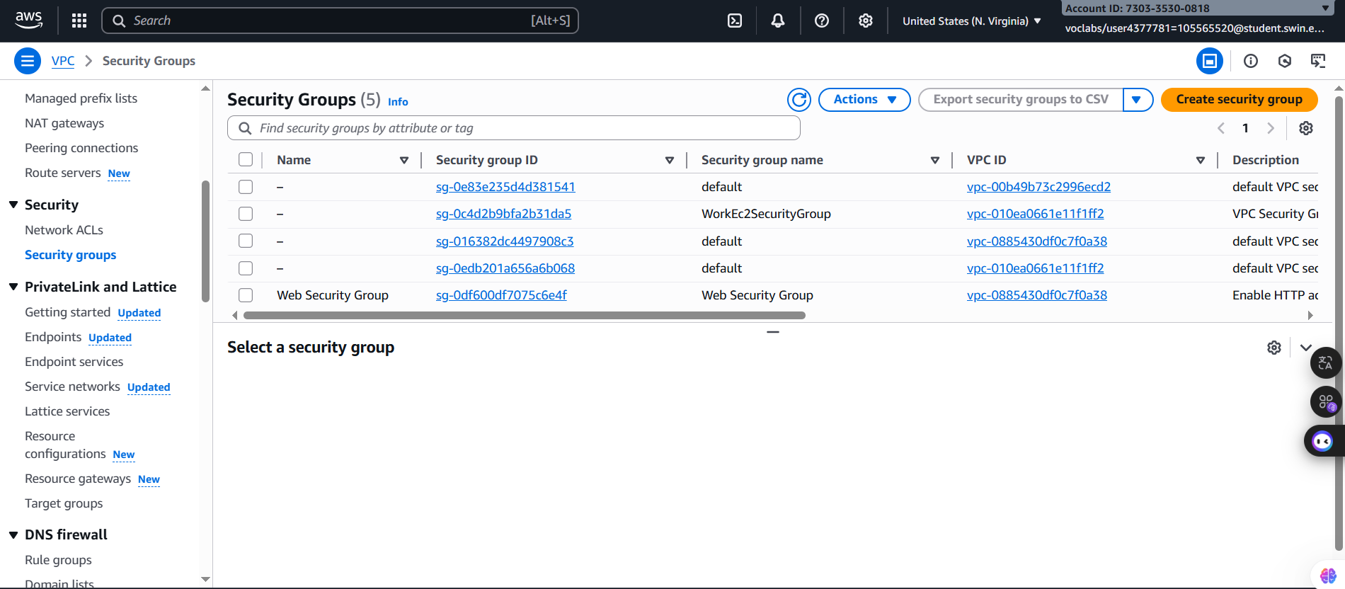
Step 1.2: Choose the Security Groups in the left naviagtion pane in the VPC Homepage
Figure 3: VPC Security Groups

Step 1.3: After choosing the , configure the following settings:

- Security group name: DB Security Group
- Description: Permit access from Web Security Group
- VPC: Lab VPC
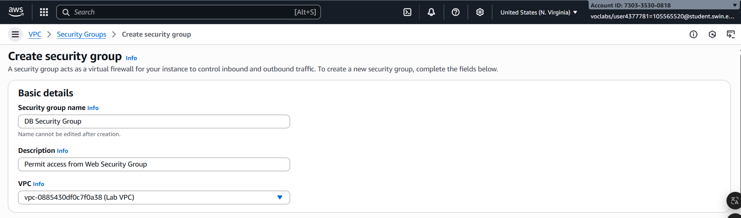
Tip: Choose the X next to VPC that is already selected, then choose Lab VPC from the menu.
Figure 4: Basic details Configuration

Step 1.4: Then, choosing the in the Inbound rules with following configurations:
- Type: MySQL/Aurora (3306)
- Source: Place you cursor in the field to the right of Custom, type sg, and then select Web Security Group.
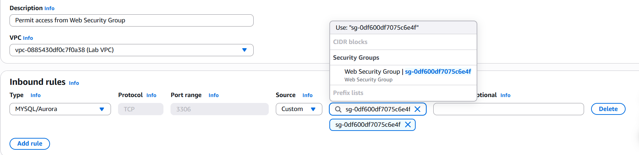
Figure 5: Inbound Configuration
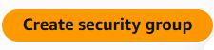
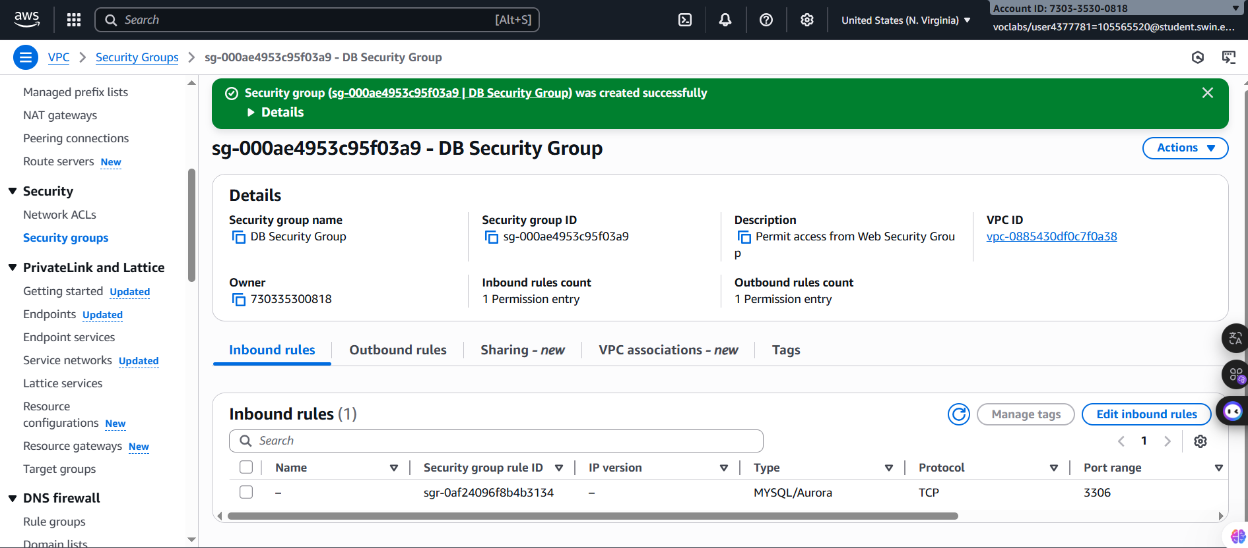
Step 1.5: After configure these settings, clicking the button on the bottom of the page
Figure 6: Security group created succeassfully

D. Task 2: Create a DB Subnet Group
In this task, you will create a DB subnet group that is used to tell RDS which subnets can be used for the database. Each DB subnet group requires subnets in at least two Availability Zones.
Step 2.1: In the search box of VPC page next to the service icon, search and choose the Aurora and RDS

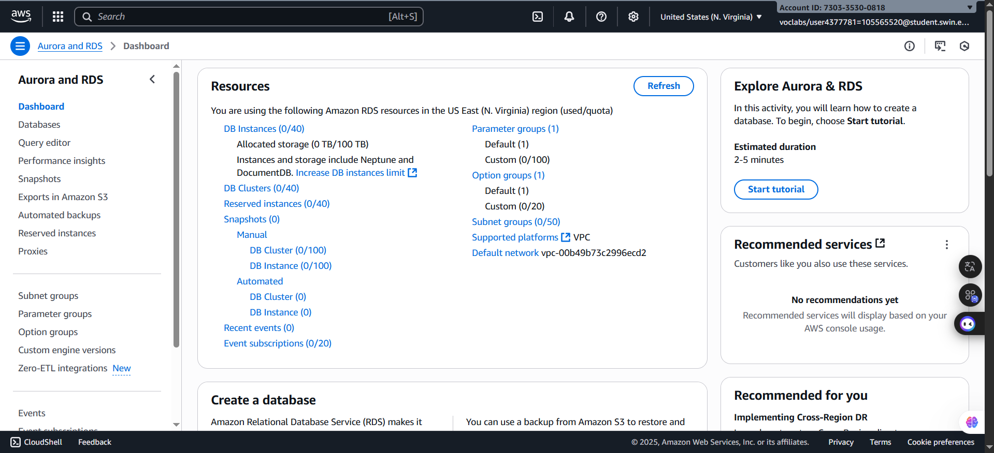
Figure 7: Aurora and RDS Homepage

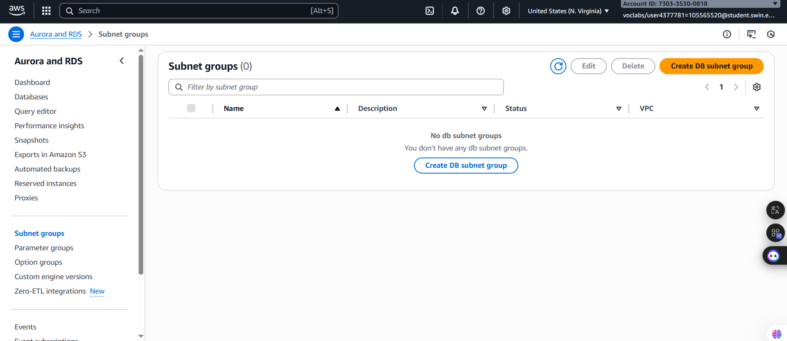
Step 2.2: Choose the Subnets groups in the left navigation
Figure 8: Aurora and RDS Homepage

Step 2.3: Clicking the and create a new DB group with below settings:
- Name: DB-Subnet-Group
- Description: DB Subnet Group
- VPC: Lab VPC

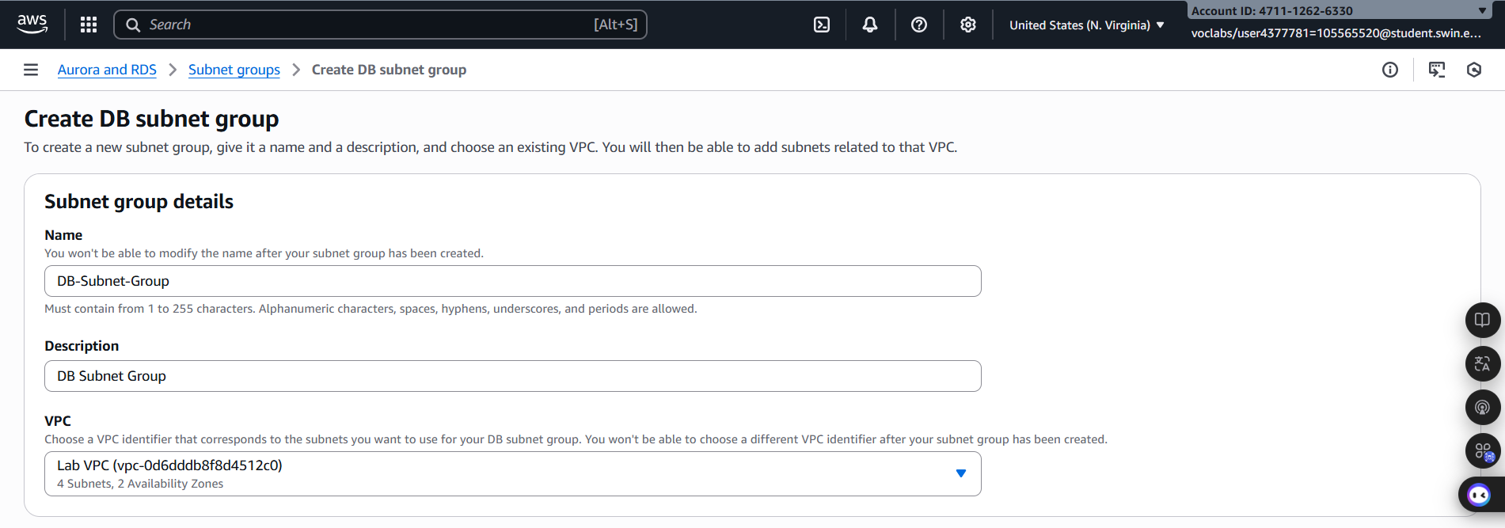
Figure 9: Subnet Group Details Configuration

Step 2.4: Then, srolling down to the Add Subnets section and edit it with following configurations:
- Availability Zones: us-east-1a and us-east-1b
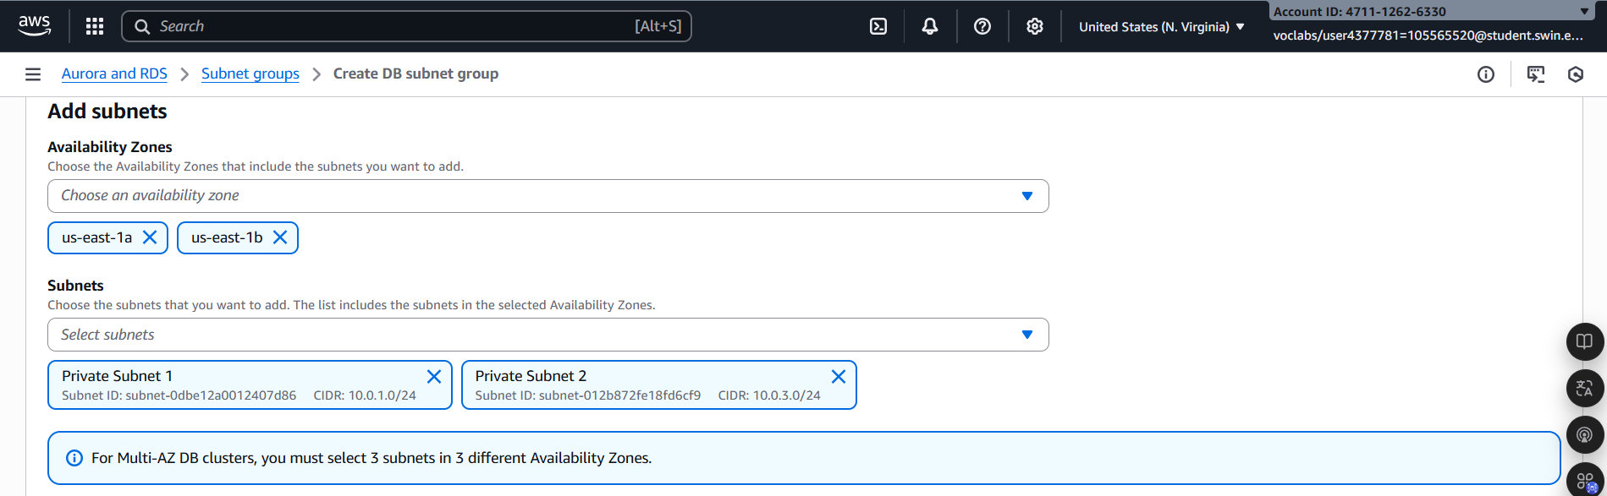
- Subnets: 10.0.1.0/24 and 10.0.3.0/24.

Figure 10: Add subnets Configuration

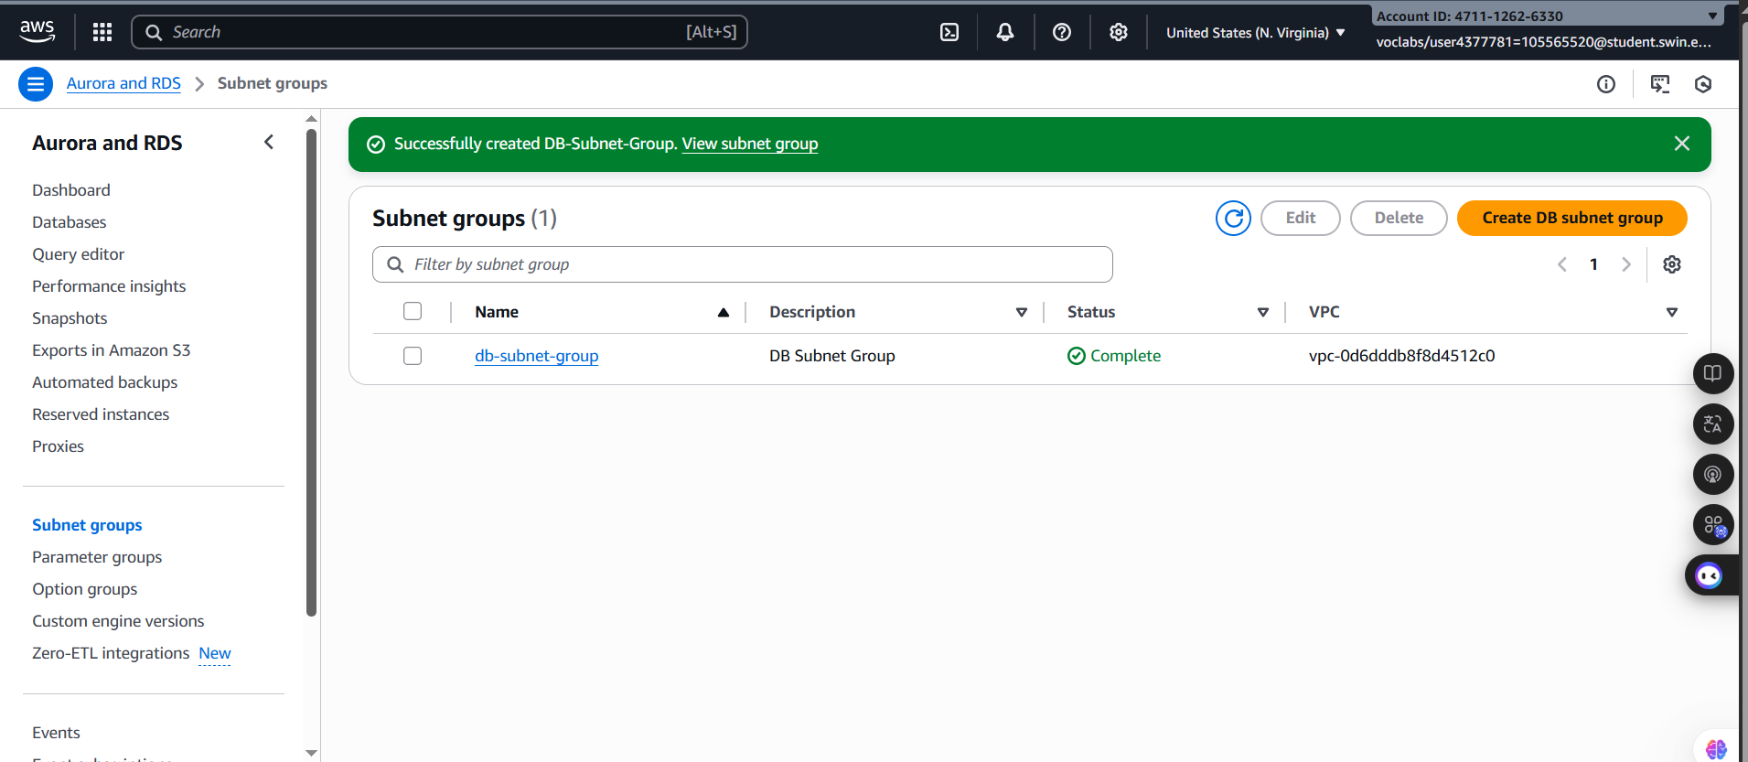
Step 2.5: After rewatching and confirming the configuration is correct, select
Figure 11: DB subnet group created successfully
E. Task 3: Create an Amazon RDS DB Instance
In this task, you will configure and launch a Multi-AZ Amazon RDS deployment of a MySQL database instance.

Amazon RDS Multi-AZ deployments provide enhanced availability and durability for Database (DB) instances, making them a natural fit for production database workloads. When you provision a Multi-AZ DB instance, Amazon RDS automatically creates a primary DB instance and synchronously replicates the data to a standby instance in a different Availability Zone (A:Z).

Step 3.1: Next, on the left navigation pannel, choose Databases and then click the button to create database. After that, configure these settings:

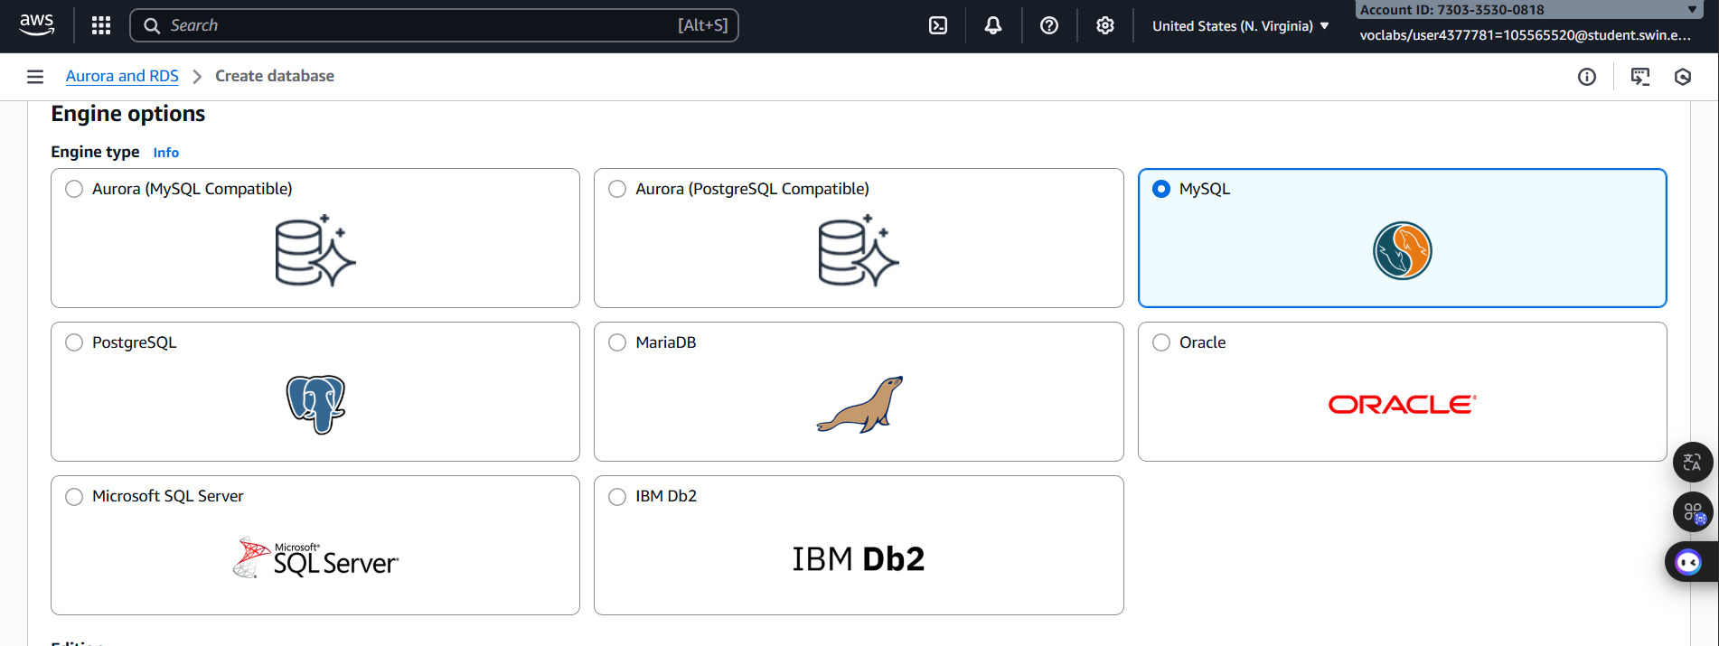
- Engine type: MySQL

Figure 12: Engine configuration

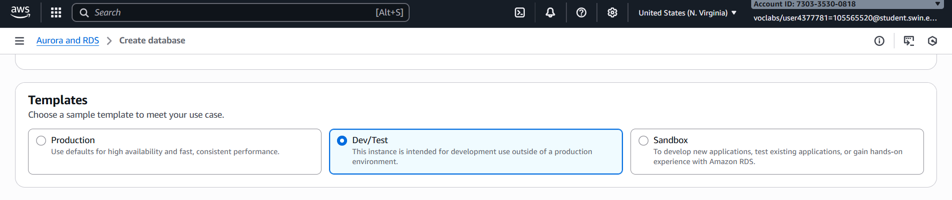
- Templates: Dev/Test

Figure 13: Templates configuration

- Availability and durability: Multi-AZ DB instance.
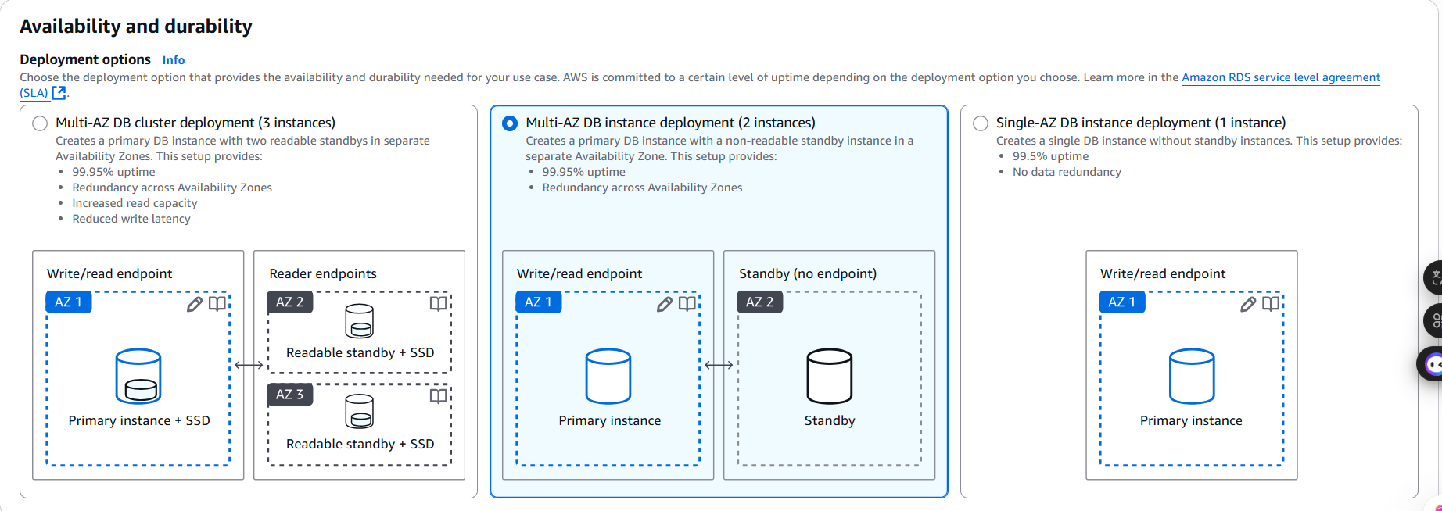
Figure 13: Availability and durability configuration

- Under Settings, configure:
- DB instance identifier: lab-db
- Master username: main
*Note: For creating password, choose Self Managed
- Master password: lab-password
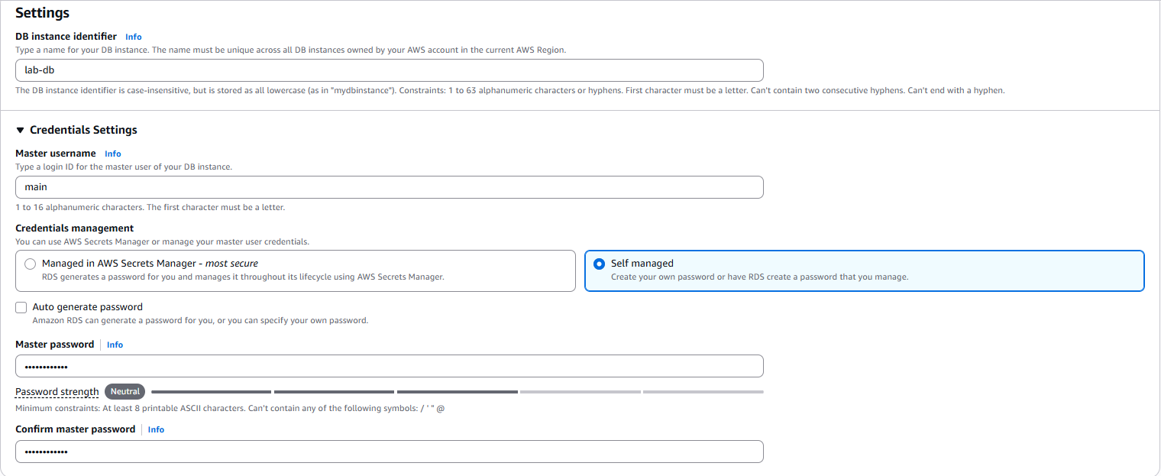
- Confirm password: lab-password
Figure 14: Settings configuration

- Under DB instance class
- Select DB instance class: Burstable classes (includes t classes).
- Select db.t3.micro
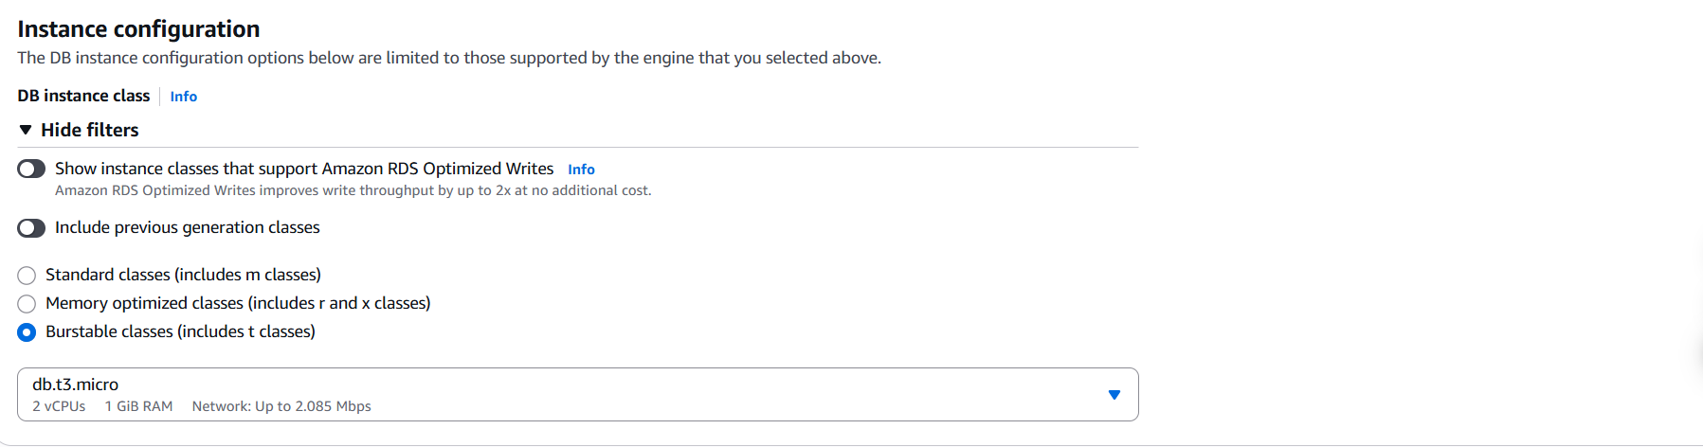

Figure 15: DB instance class configuration

- Under Storage, configure:
- Storage type: General Purpose (SSD)
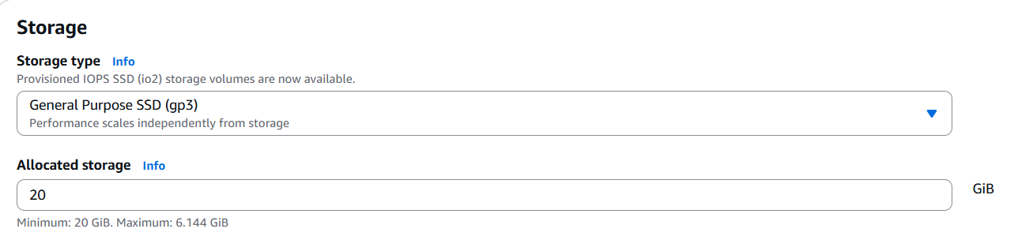
- Allocated storage: 20
Figure 16: Storage configuration

- Under Connectivity, configure: Virtual Private Cloud (VPC) - Lab VPC
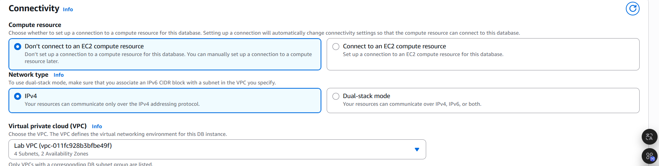
Figure 17: Connectivity configuration

- Under Existing VPC security groups, from the dropdown list:
- Choose DB Security Group.
- Deselect default.
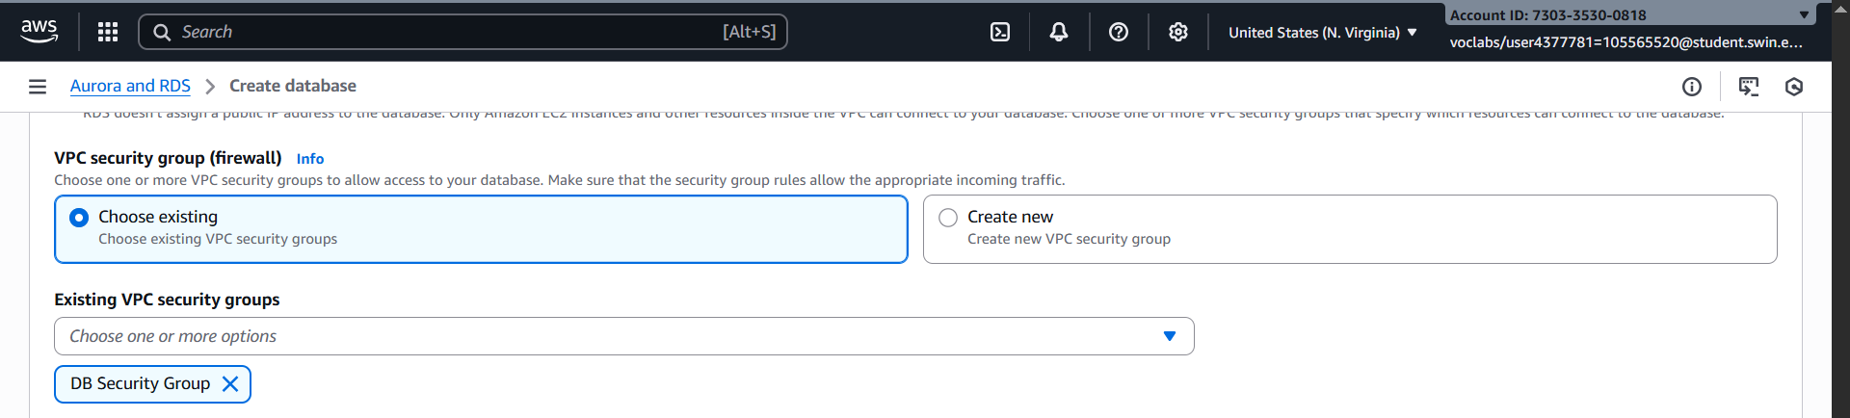
Figure 17: VPC configuration

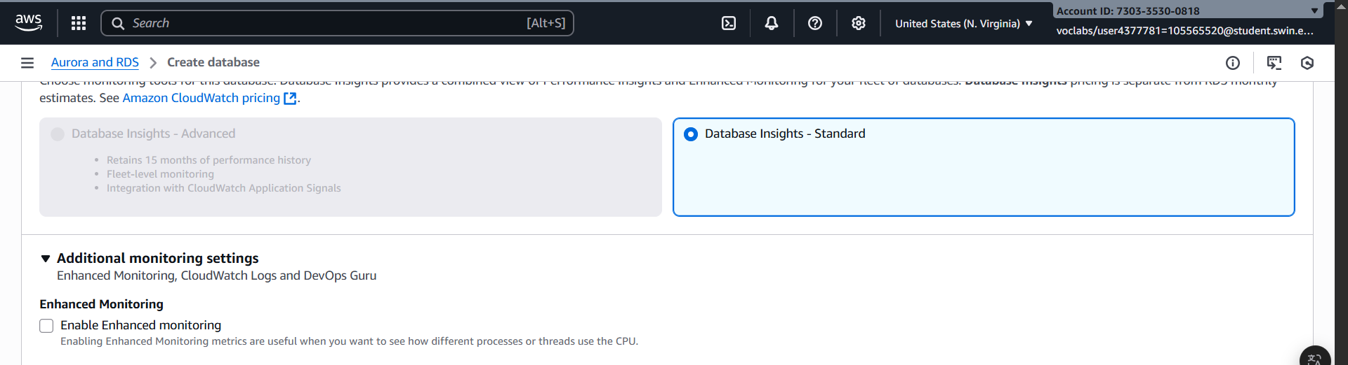
- Next, click the Aditional configuration and deselect Enable Enhanced monitoring.
Figure 18: Uncheck the Enable Enhanced monitoring

- Next, expand the Additional configuration:
- Initial database name: lab
- Uncheck Enable automatic backups.
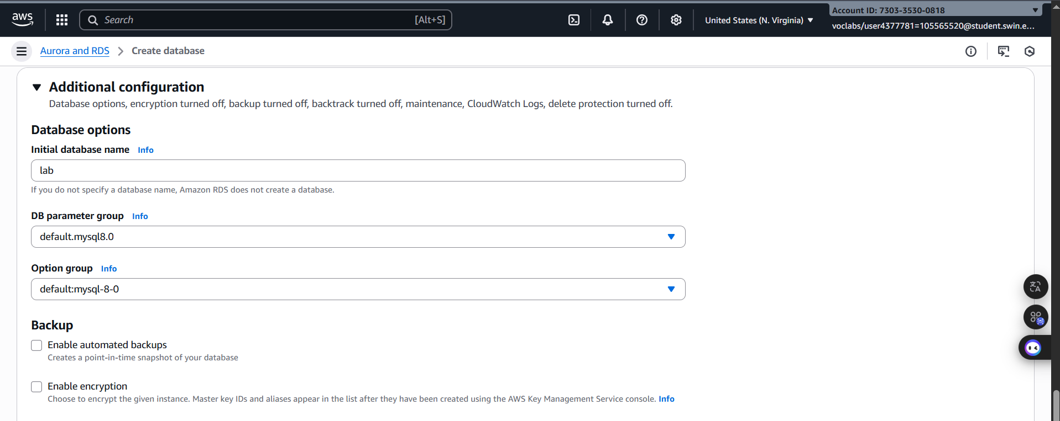
- Uncheck Enable encryption

Figure 19: Additional Configuration

- After clicking the button , wait approximately 4 minutes to launch the database available
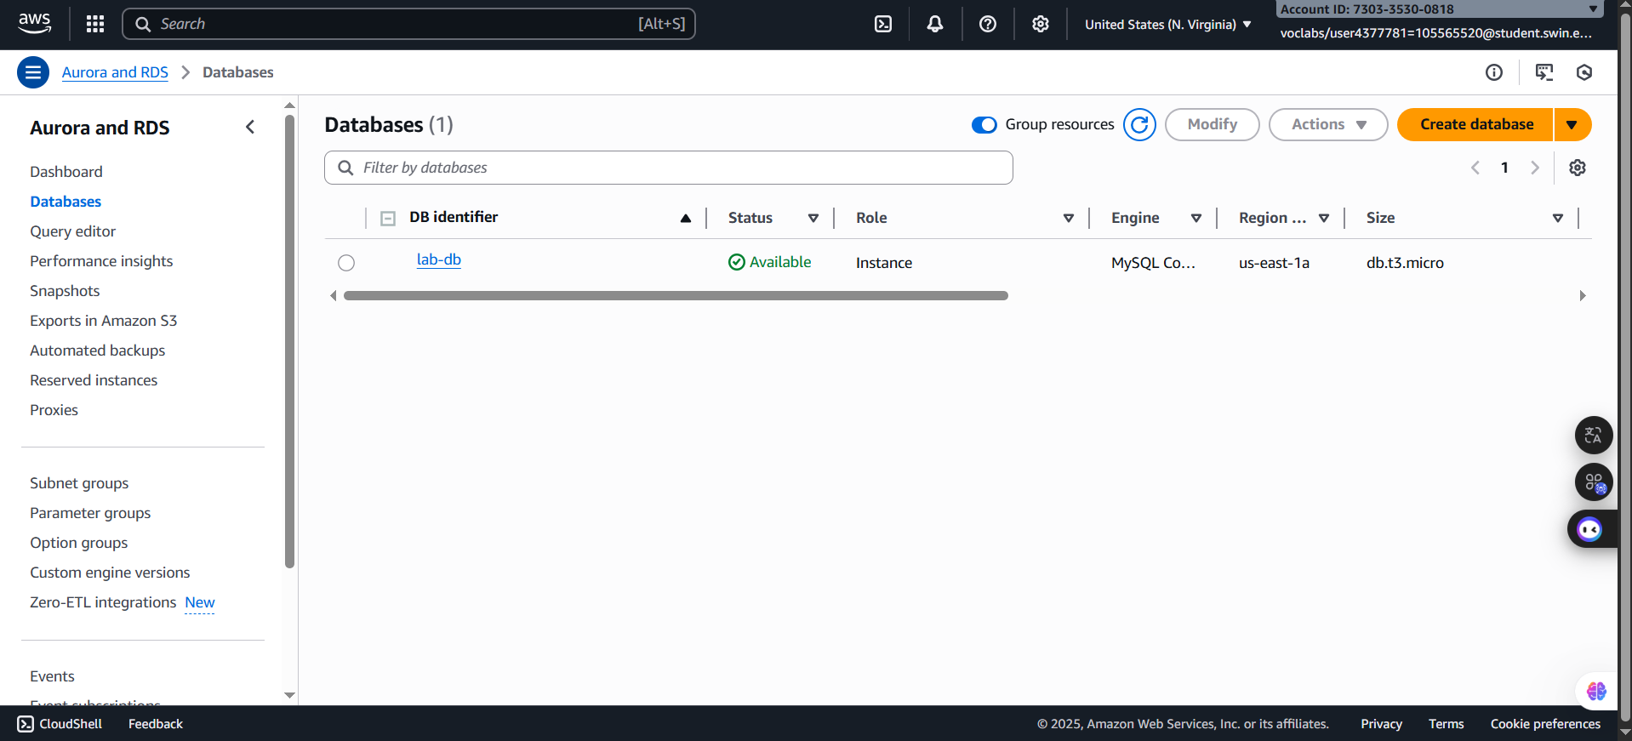
Figure 20: Database available

Step 3.2: Click the lab-db itself, scroll down to the Connectivity & security section and copy the Endpoint. Then, copy the endpoint and paste it into the text editor

F. Task 4: Interact with Your Database
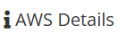
Step 4.1: Choose the on the top right corner
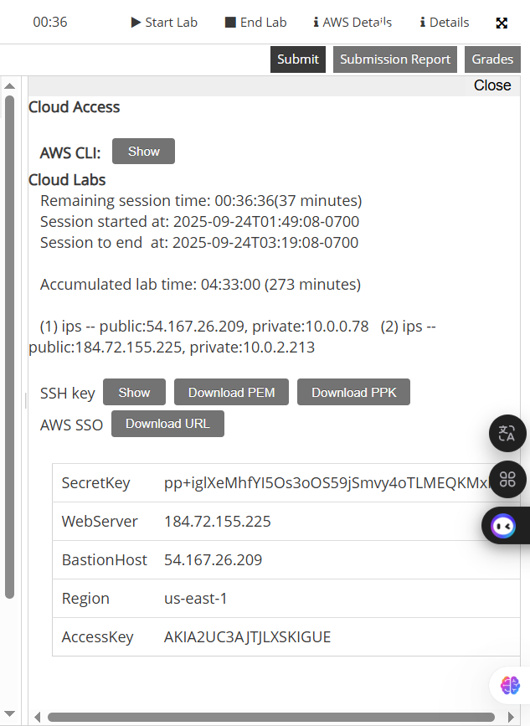
Figure 21: AWS Details

Step 4.2: Pate the Webserver link into a new browser tab
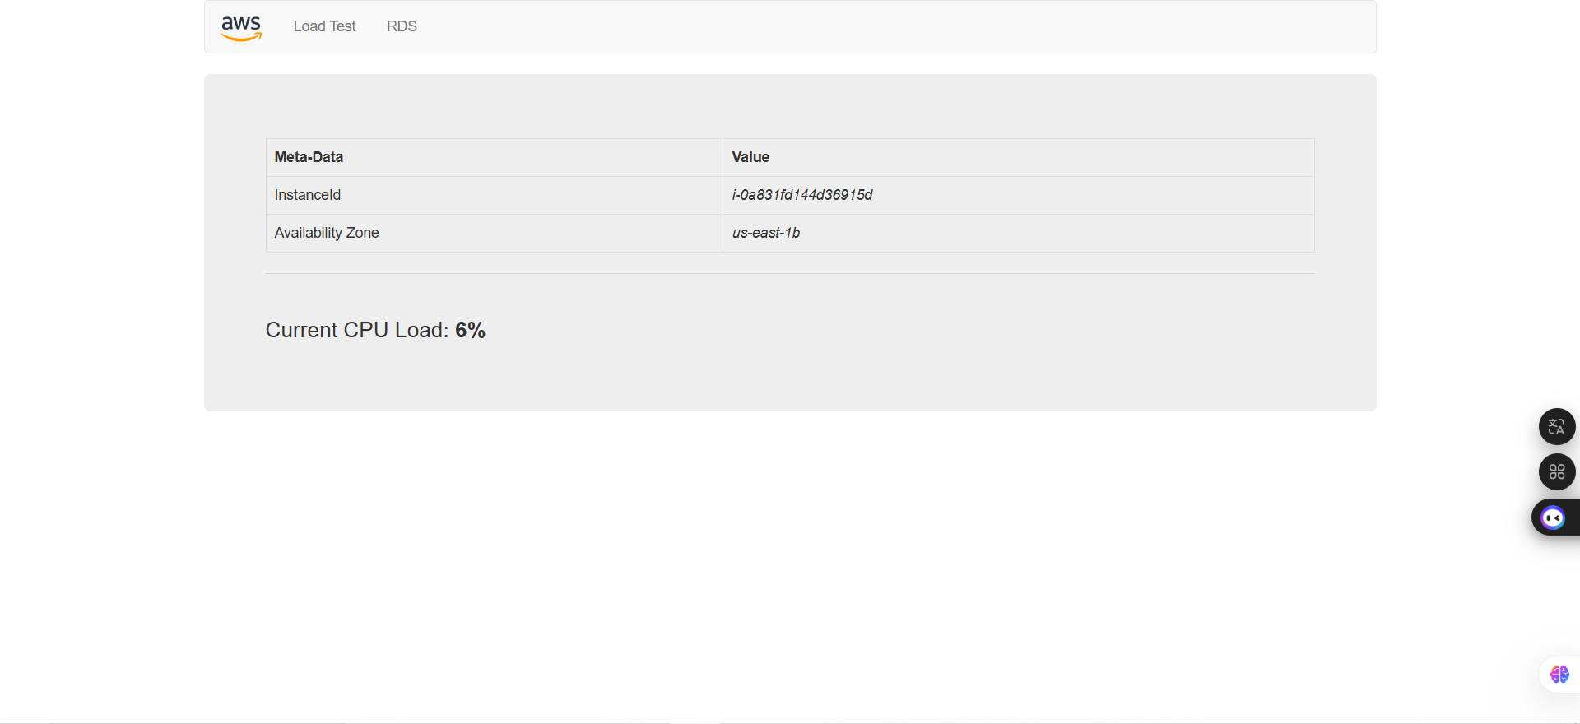

Figure 22: Webserver page

Step 4.3: Choose the RDS and then configure following settings:
- Endpoint: lab-db.c16agicay2t3.us-east-1.rds.amazonaws.com
- Database: lab
- Username: main
- Password: lab-password
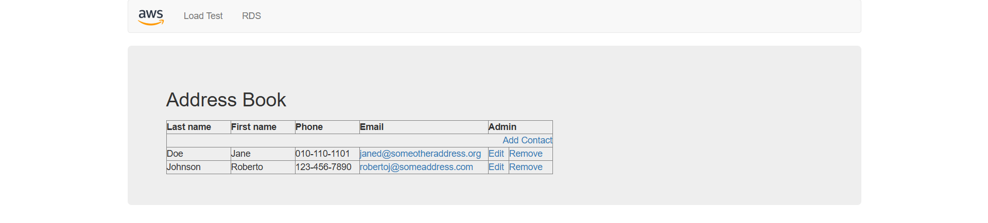
And finally click Submit

Figure 23: Address Book page

Step 4.4: Try to adding, editing and removing contactson the web application.

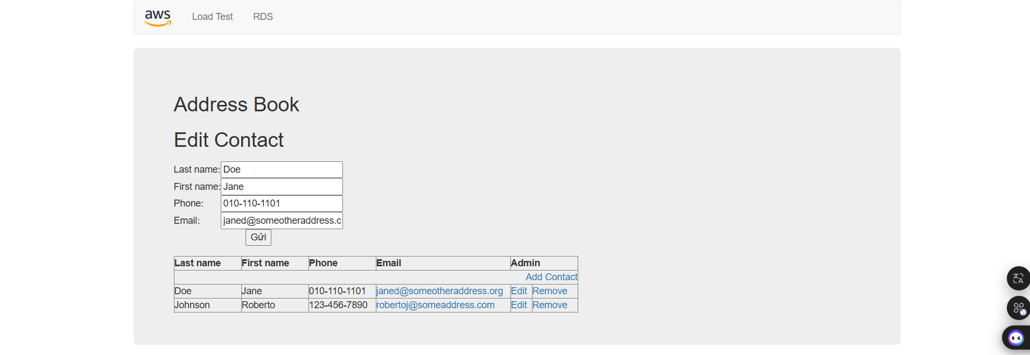
Figure 24: Edit Data processing
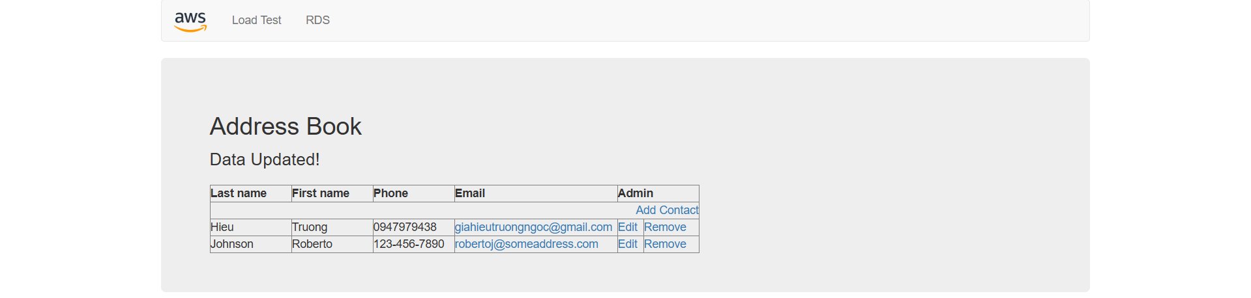
Figure 25: Edit data successfully
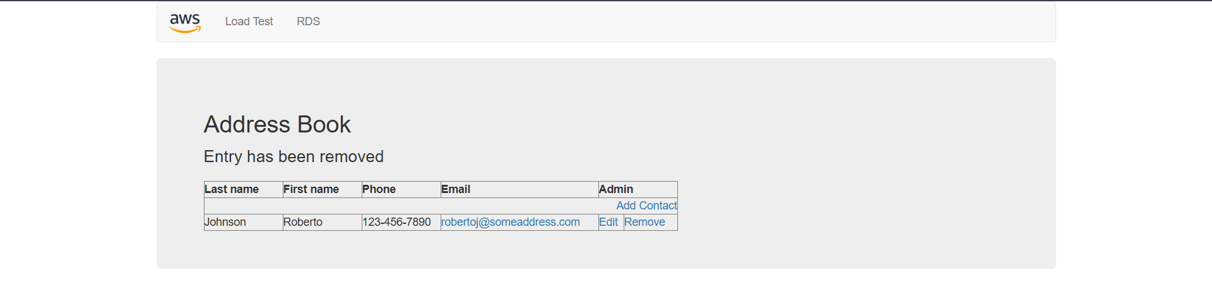
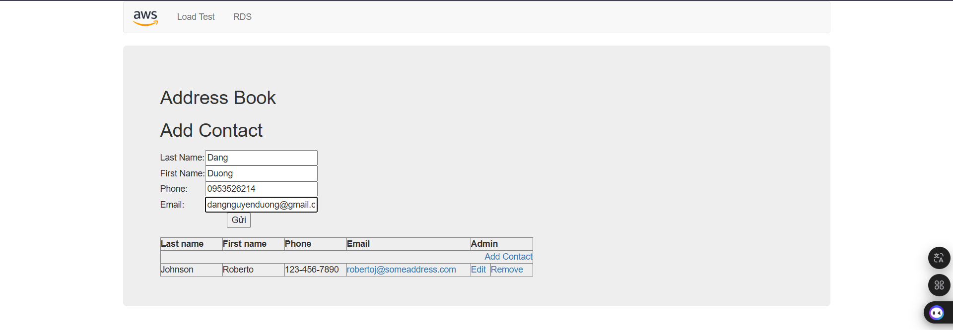
Figure 26: Remove data successfully

Figure 27: Add data process

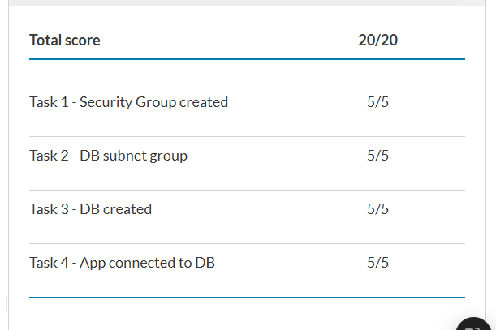
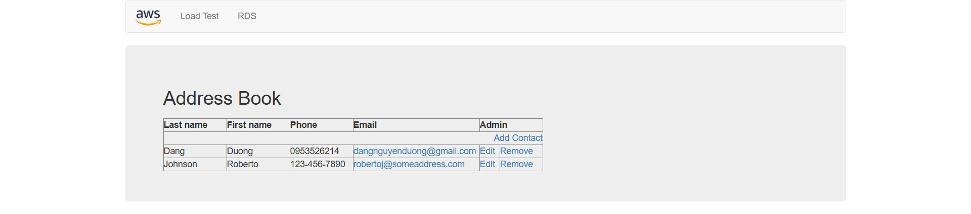
Figure 28: Add data successfully

Figure 29: Completely lab

G. Conclusion
- In this lab, I learned how to set up and work with Amazon RDS by creating a relational database instance with high availability. I started by configuring security groups and subnet groups, then launched a Multi-AZ RDS MySQL instance. After that, I connected the database to a web application and successfully added, edited, and removed data through the app.
- Through this process, I gained hands-on experience with managed database services in AWS. I understood how Amazon RDS simplifies database administration tasks such as scaling, availability, and security, while still allowing me to interact with the database like a traditional system. This lab helped me build confidence in deploying and managing relational databases in the cloud, which is an important skill for real-world applications.

